# **Qualification Round Submission**

Name: Debasis Behera

Email: debasisbehera@gmail.com

College: Indira Gandhi Institute of Technology

Date: 10-07-2025

Problem Statement

Compute zigzag diagonal sum in a matrix of size NxN, adding non-primes and subtracting primes using pointer traversal only.

Solution:

#include <stdio.h>

#include <stdlib.h>

int isPrime(int num) {

    if (num <= 1) return 0;

    for (int i = 2; i*i <= num; i++)

        if (num % i == 0) return 0;

    return 1;

}

int compute_zigzag_sum(int** matrix, int n) {

    int sum = 0, val;

    for (int d = 0; d <= 2 * (n - 1); d++) {

        for (int i = 0; i <= d; i++) {

            int r = (d % 2 == 0) ? i : d - i;

            int c = (d % 2 == 0) ? d - i : i;

            if (r < n && c < n) {

                val = *(*(matrix + r) + c);

                sum += isPrime(val) ? -val : val;

            }

        }

    }

    return sum;

}

int main() {

    int n, **matrix;

    printf("Enter matrix size (n): ");

    scanf("%d", &n);

    matrix = (int**)malloc(n * sizeof(int*));

    for (int i = 0; i < n; i++)

        *(matrix + i) = (int*)malloc(n * sizeof(int));

    printf("Enter %d elements:\n", n * n);

    for (int i = 0; i < n; i++)

        for (int j = 0; j < n; j++)

            scanf("%d", (*(matrix + i) + j));

    printf("Final Zigzag Sum: %d\n", compute_zigzag_sum(matrix, n));

    for (int i = 0; i < n; i++) free(*(matrix + i));

    free(matrix);

    return 0;

}

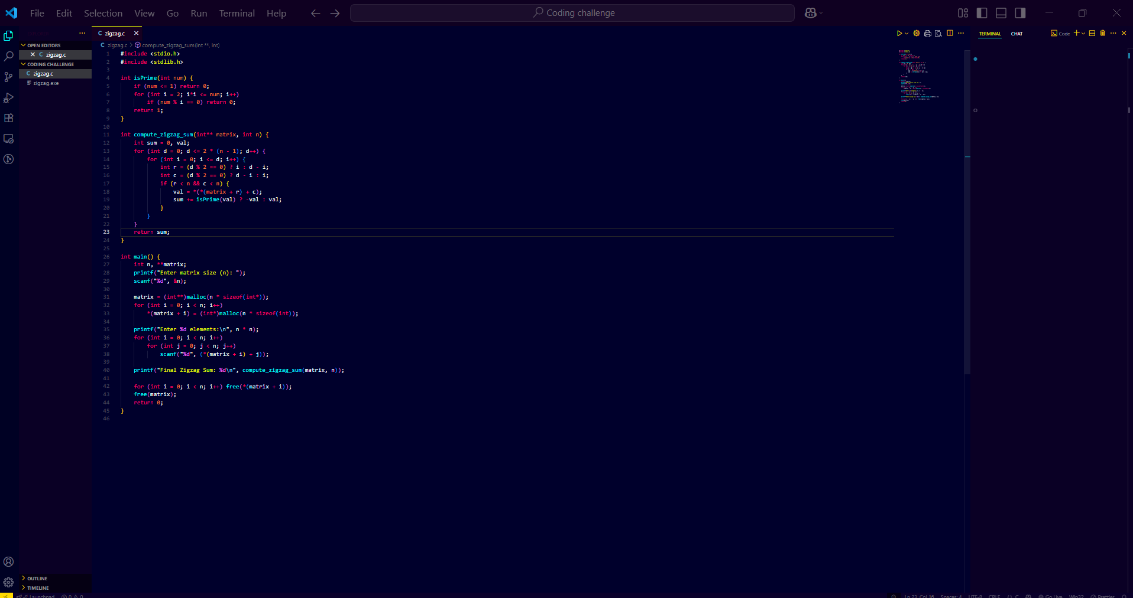

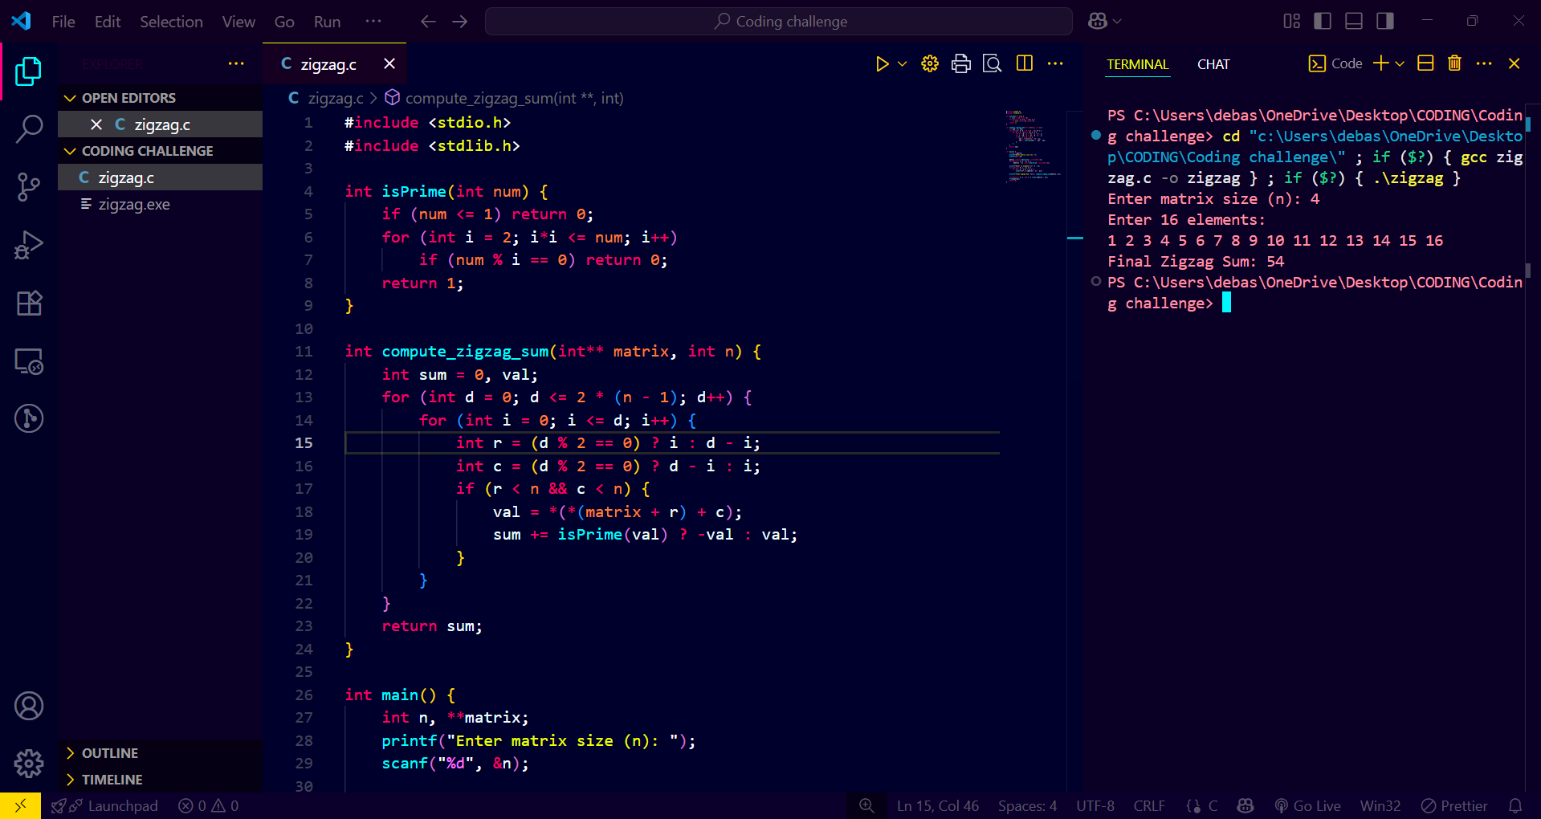

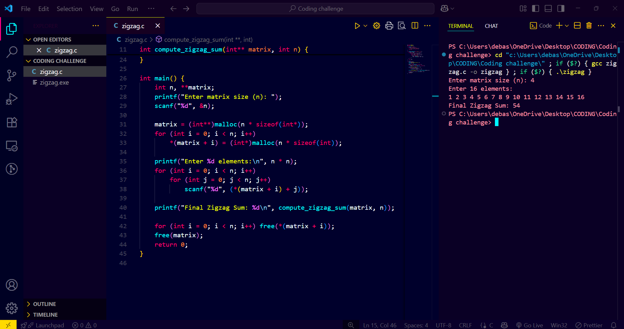

Video link:-

<https://drive.google.com/file/d/1Jt5wDwVVV6fXnkShqmJJaGXii2SIYiE5/view?usp=sharing>

Thank you